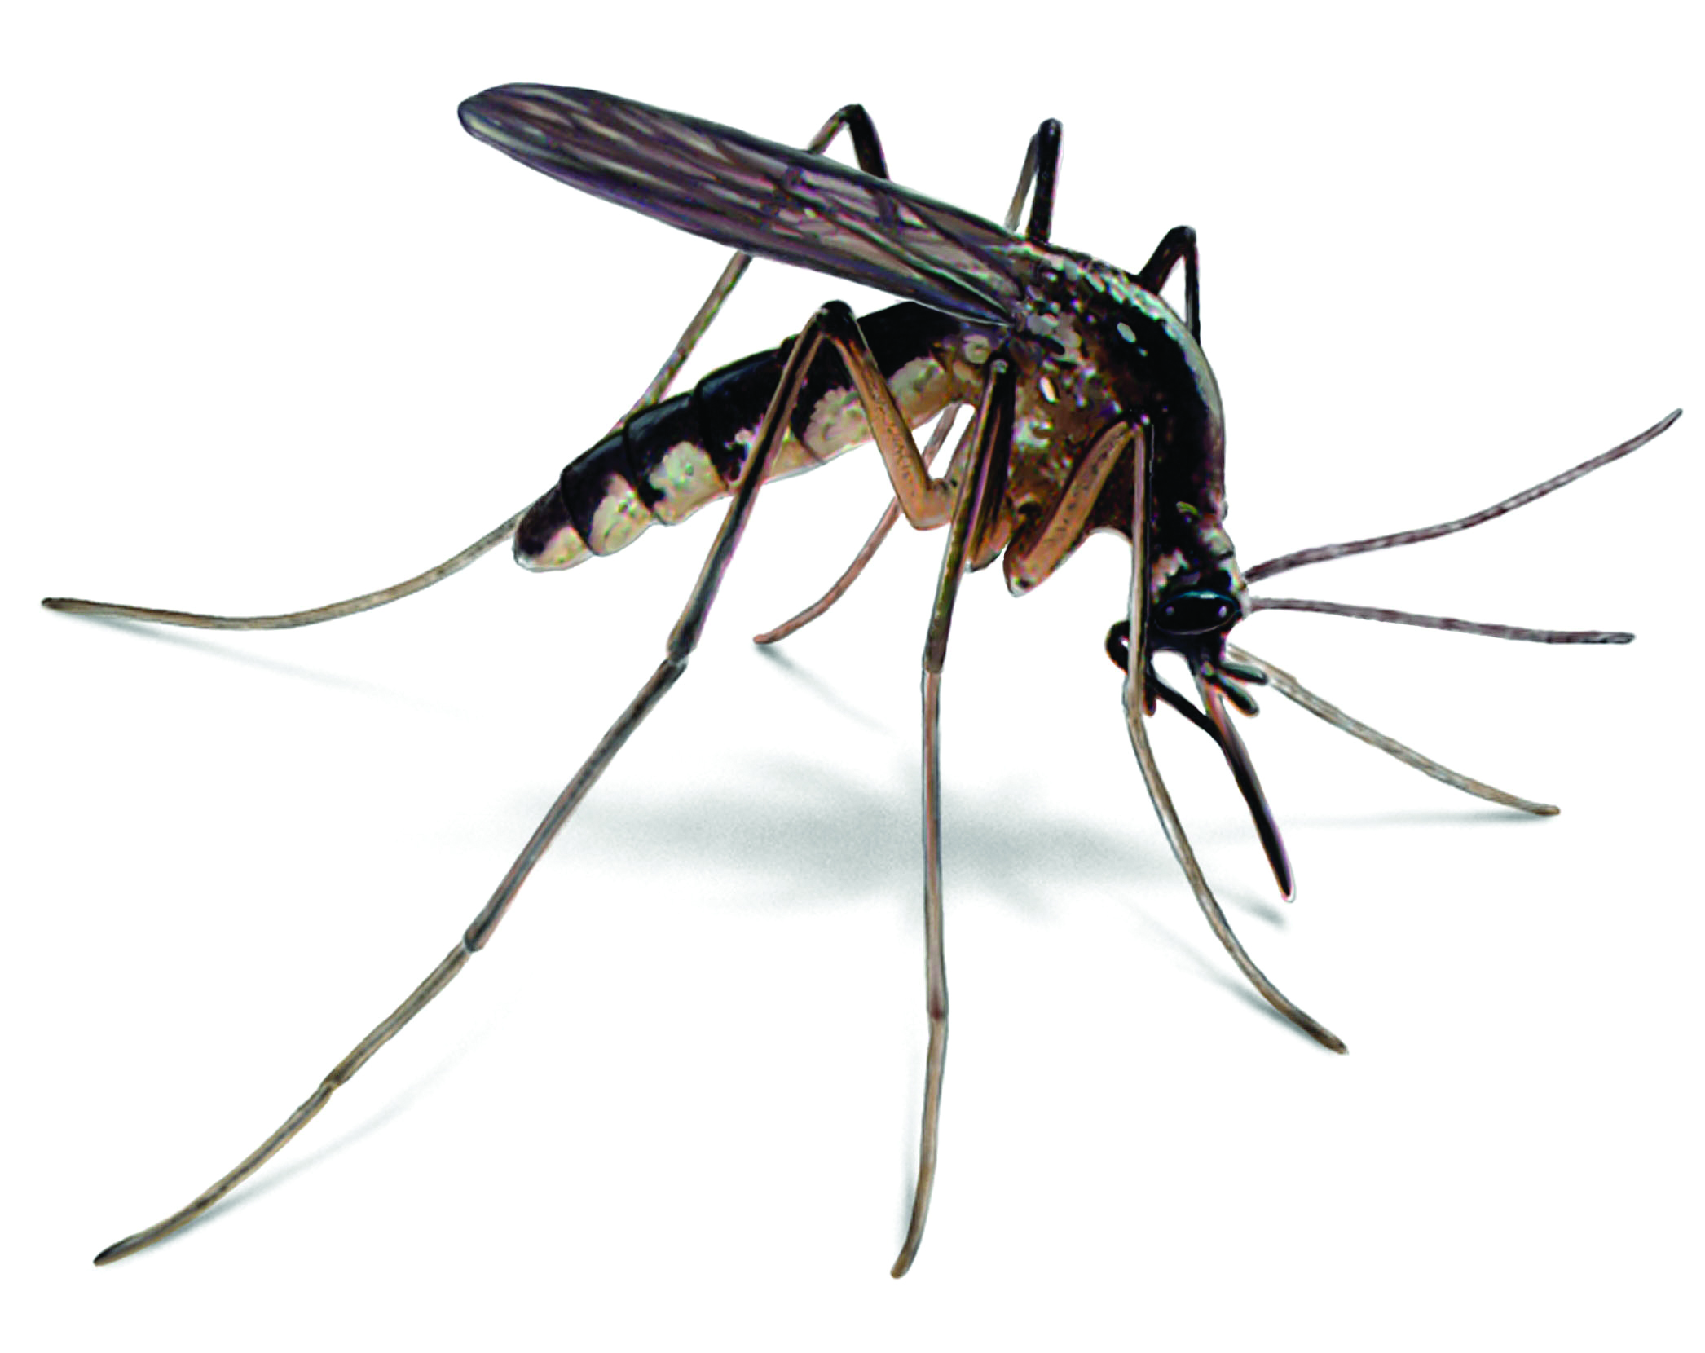 Mosquito Spraying Schedule
The City of Miner will spray Adulticides chemicals for mosquitos during the late evening hours twice a week. The schedule is dependent upon weather conditions such as rain and wind. Please report any stagnant water that may be a breeding ground for mosquitos. The City is able to treat stagnant water with chemicals that will reduce the larvae.
Adulticides

are pesticides that kill adult mosquitoes. The active ingredients in adulticides work by stopping the mosquito’s brain from working properly. Adulticides are used by spraying the product from a truck using a very small amount of the pesticide (less than 4 ounces per acre of land). The liquid comes out of the truck- mounted sprayer as a mist of very small drops or a "fog". The fog floats with the air currents. Mosquitoes must come into contact with the fog to be killed. Mosquito spraying is done in the evening after sunset or in the morning before sunrise when most mosquitoes are flying instead of resting.

The most effective way to avoid West Nile virus disease is to prevent mosquito bites. Be aware of the West Nile virus activity in your area and take action to protect yourself and your family
The Mosquito Control Program works to prevent the spread of mosquito-transmitted diseases, such as West Nile, Chikungunya and Zika viruses to the public. Information concerning the control of a variety of pests, including rats, roaches, and other insects, is also available on the CDC website. http://www.cdc.gov/westnile/prevention/index.html
Remember the Four Ds:
DRAIN: Drain or treat all standing water in and around your home or workplace. Standing water can be found in swimming pools that are not kept clean, ponds, pet watering dishes, birdbaths, potted plants, old tires, empty containers, toys and clogged rain gutters.
DUSK/DAWN: Limit outdoor activities during dusk and dawn when mosquitoes are most active.
DRESS: Wear long, loose, and light-colored clothing outside.
DEET All Day, Every Day: Whenever you're outside, use insect repellents that contain DEET or other EPA approved repellents and follow instructions.

